## Scan

The Scan tab allows the user to actively scan for nearby Access Points.

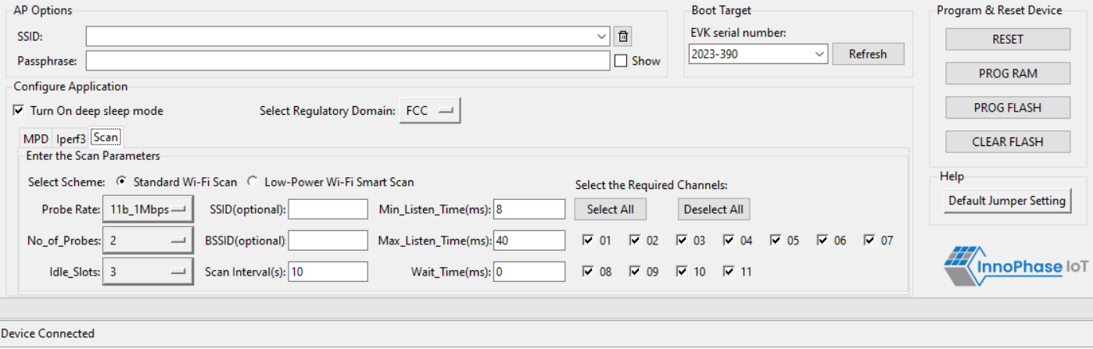

Figure 18: Scan tab

**Choose the Scheme**: User can choose Standard Wi-Fi Scan or Low-Power Wi-Fi Smart Scan for scanning.

1. **Standard Wi-Fi Scan**: In this scan mode, Talaria TWO scans each channel with the configured scan time (default being 40ms).
2. **Low Power Wi-Fi Smart Scan**: In this scan mode, Talaria TWO reduces the overall current consumption by enabling dynamic dwelling and napping features.

The following scan parameters can be configured from the tool:

1. SSID (optional): Providing the SSID helps enable scan for a specific AP.
2. BSSID (optional): Providing the BSSID helps enable scan for a specific AP.
3. No_of_probes: Maximum number of probes to send in an active scan.
4. Idle slots: Maximum number of idle slots to decide whether the user should keep listening or not.
5. Min_Listen_Time(ms): Minimum amount of time (in milliseconds) to listen for probe responses on the channel after transmitting the probe request.
6. Max_Listen_Time(ms): Maximum amount of time (in milliseconds, including listen and probe requests) to stay on the channel.
7. Wait_Time(ms): Idle time between each channel (giving other parties access to the media).
8. Scan Interval (ms): Time duration in milliseconds in which Talaria TWO scans the vicinity for networks.
9. Probe_rate: The rate as defined by rate_t used to transmit the probe request. If this field is set to 0xffff, no probes will be sent and the scan will only be passive.